TERRAFORM TASK – 02

1. Task Objective
I completed the Terraform practical in two parts:
- I executed the Terraform templates: local_file, random_pet, lifecycle rules and variables.
- I integrated Terraform with Jenkins through GitHub, the Terraform plugin, Terraform configuration and a Jenkins pipeline.
The practical was completed on an Amazon Linux EC2 environment for the Terraform/Jenkins work, with the Terraform exercises performed in the Terraform_basic project.

2. TASK 1 – Execute Terraform Templates

2.1 I created the Terraform project
I created the working directory and moved into it.
mkdir Terraform_basic
cd Terraform_basic
pwd
My working directory was:
/home/ec2-user/Terraform_basic
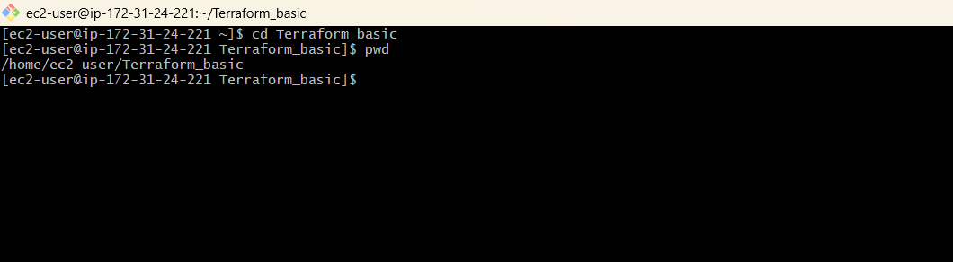

My project contained the Terraform configuration and generated files used during the practical.
Terraform_basic/
├── main.tf
├── variables.tf
├── terraform.tfstate
├── terraform.tfstate.backup
├── pets.txt / wild.txt
└── .terraform/

2.2 I created the first template – local_file
I created main.tf with the local_file resource.
resource "local_file" "my_pet" {
filename = "pets.txt"
content = "My cat name is HEN"
}
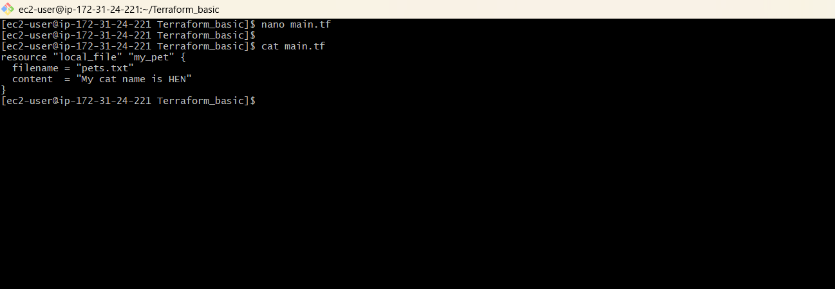
Step 1: I initialized Terraform
terraform init
Terraform initialized the working directory and downloaded the required local provider.
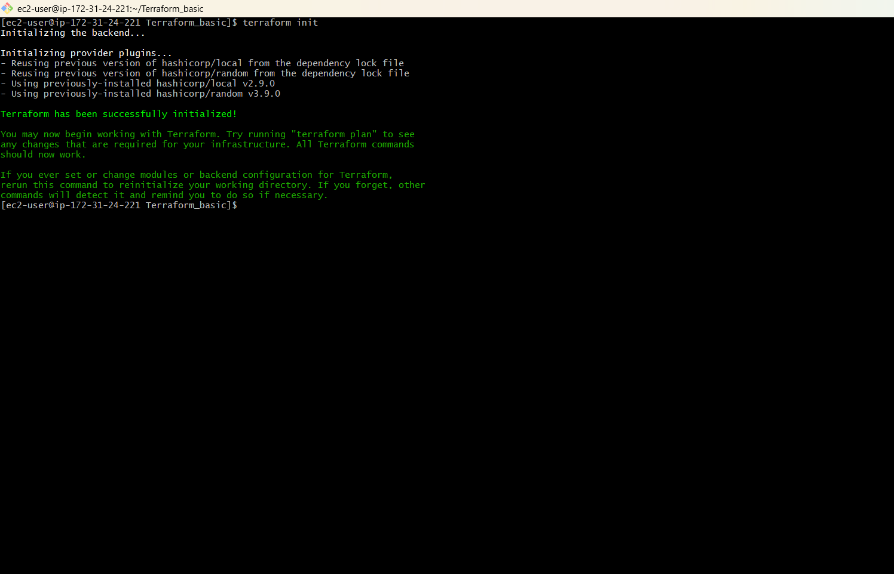
Step 2: I validated the configuration
terraform validate
Expected result: Success! The configuration is valid.
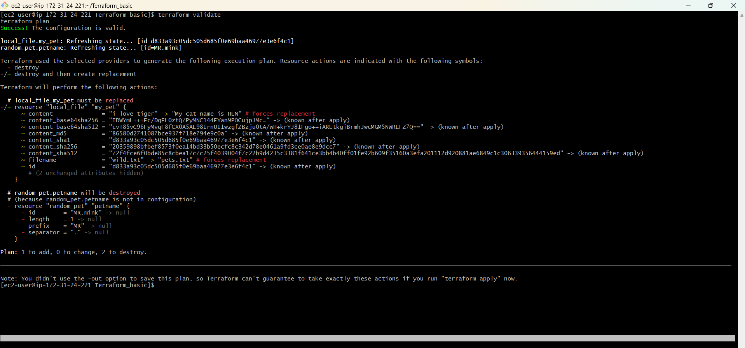
Step 3: I formatted the configuration
terraform fmt
Terraform formatted the configuration. No output was required when the file was already formatted.
Step 4: I generated the execution plan
terraform plan
The plan showed 1 resource to add.
Step 5: I applied the configuration
terraform apply
# Enter: yes
The local file resource was created successfully.
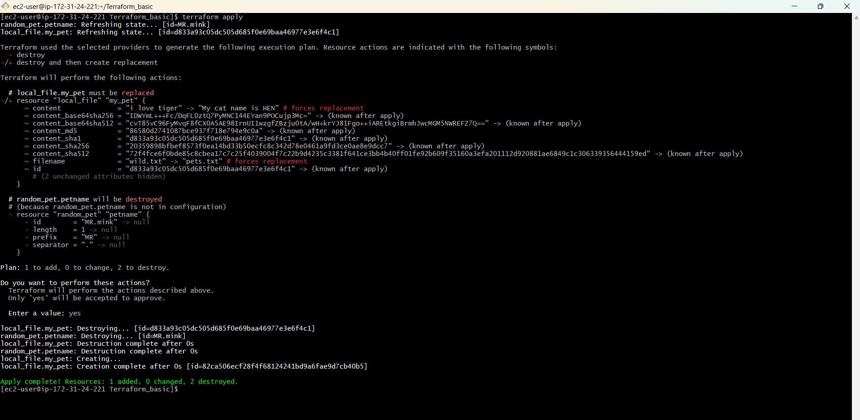
Step 6: I verified the generated file
cat pets.txt
The file contained: My cat name is HEN
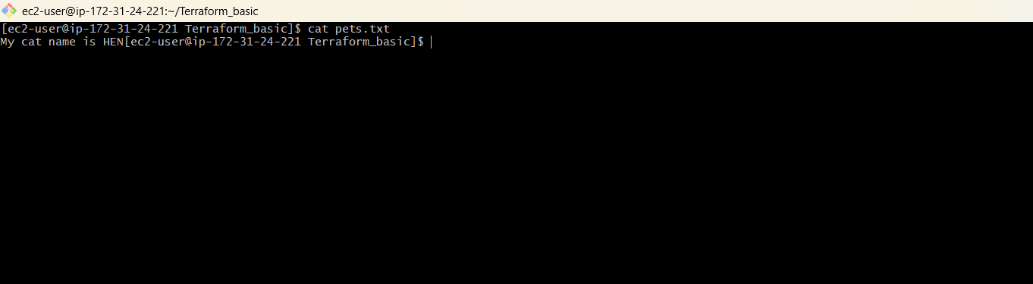

2.3 I created the second template – random_pet
I added the random_pet resource to the same Terraform configuration.
resource "random_pet" "petname" {
prefix = "MR"
separator = "."
length = 1
}
Terraform generated a random pet name. The result in my run was:
MR.mink
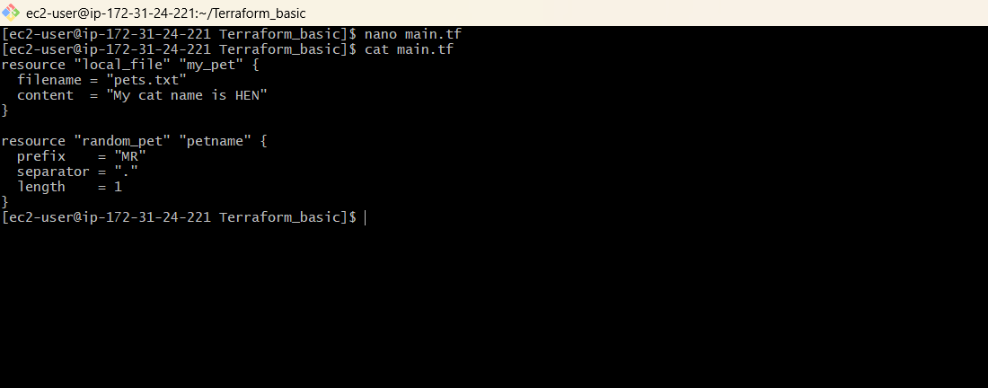

2.4 I used both resources together
resource "local_file" "my_pet" {
filename = "pets.txt"
content = "My cat name is HEN"
}
resource "random_pet" "petname" {
prefix = "MR"
separator = "."
length = 1
}
Step 1: I initialized and formatted the configuration
terraform init
terraform fmt
The configuration was initialized and formatted.
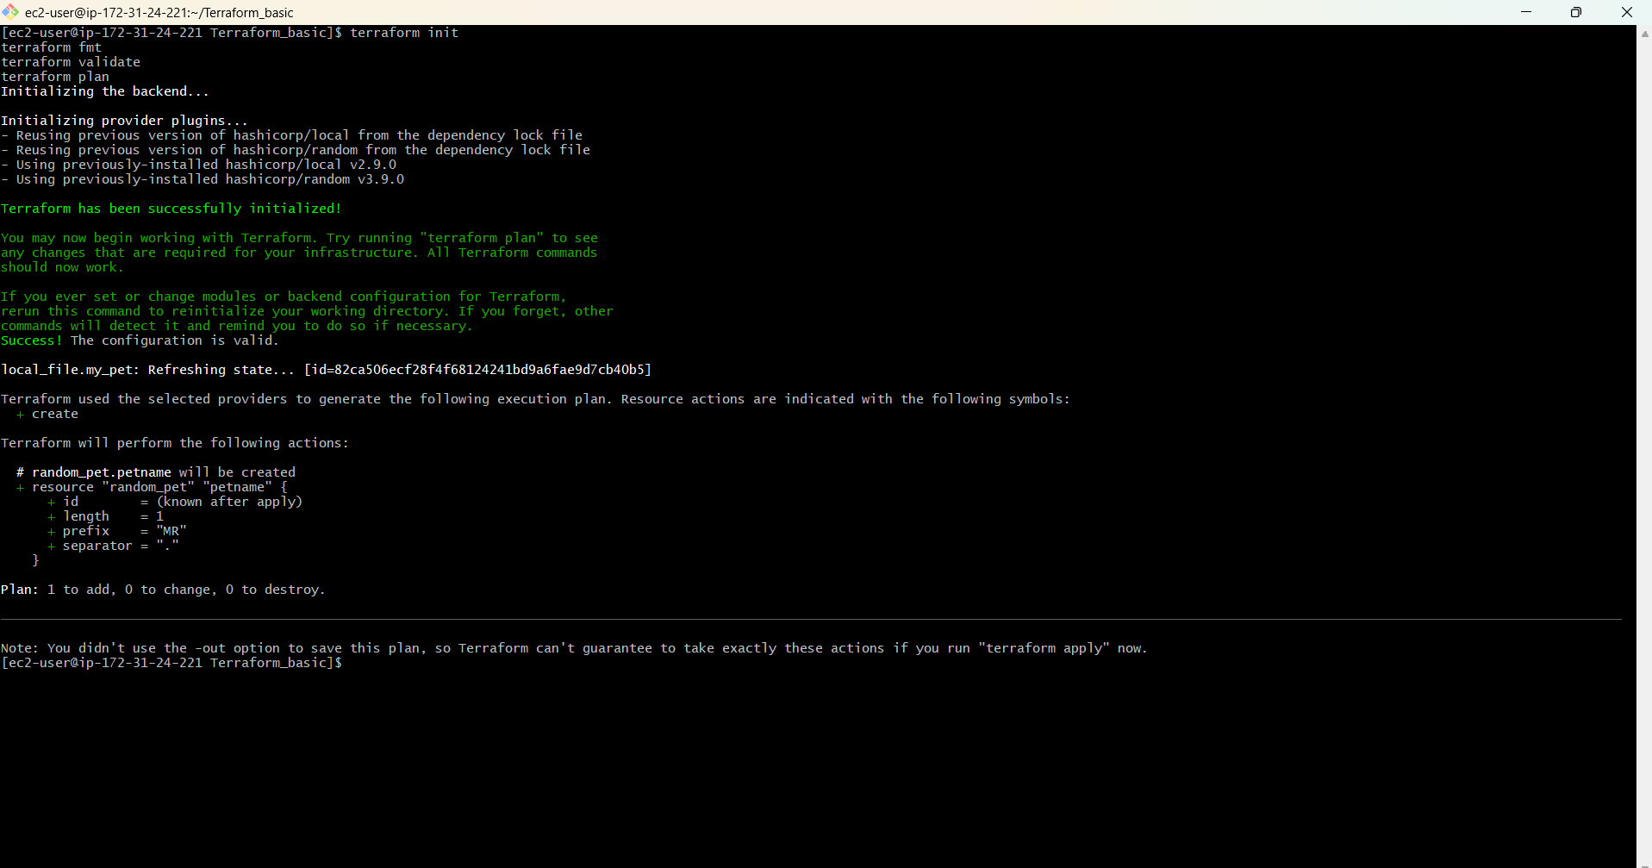
Step 2: I validated and planned
terraform validate
terraform plan
The configuration was valid and Terraform prepared the required changes.
Step 3: I applied the configuration
terraform apply
# Enter: yes
Both resources were applied.
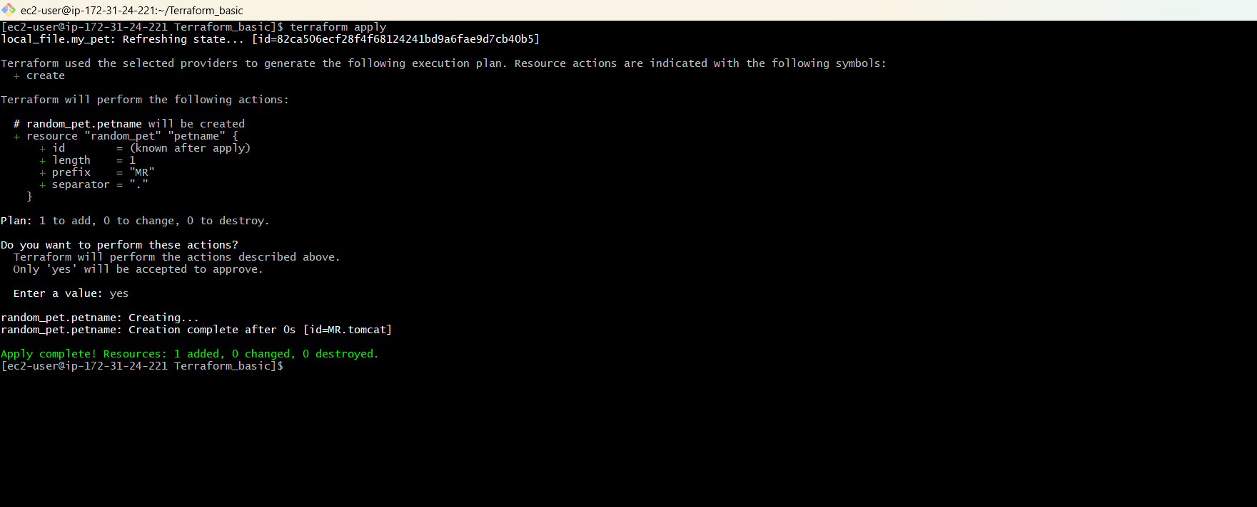
Step 4: I checked the Terraform state
terraform state list
The state contained local_file.my_pet and random_pet.petname.
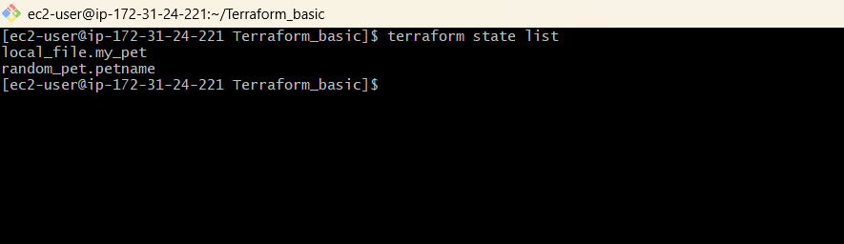

2.5 I inspected Terraform state
After applying the configuration, I inspected the Terraform state.
terraform show
terraform state list
The state list showed:
local_file.my_pet
random_pet.petname
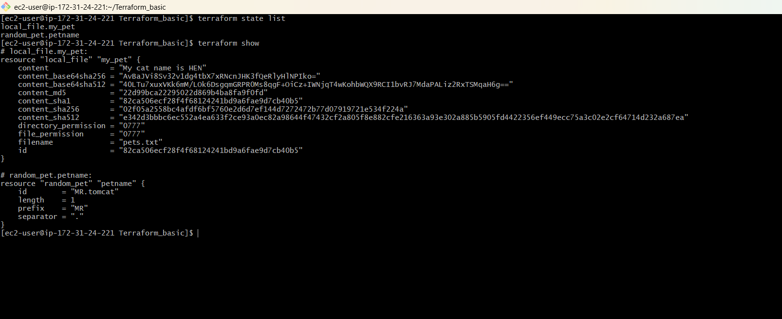

2.6 I changed the local_file resource
I changed the file content from HEN to DOG.
resource "local_file" "my_pet" {
filename = "pets.txt"
content = "My cat name is DOG"
}
resource "random_pet" "petname" {
prefix = "MR"
separator = "."
length = 1
}
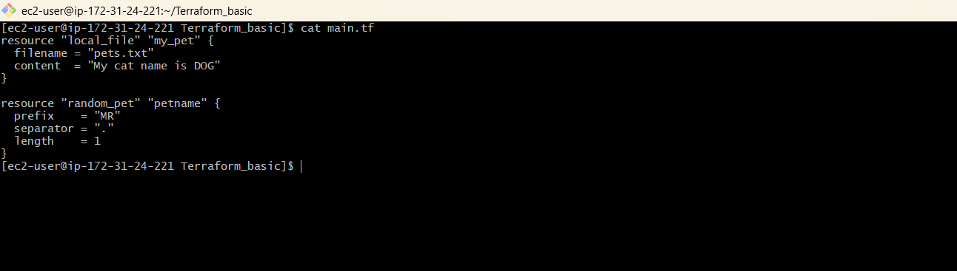Step 1: I ran terraform plan
terraform plan
Terraform detected that local_file.my_pet needed replacement.
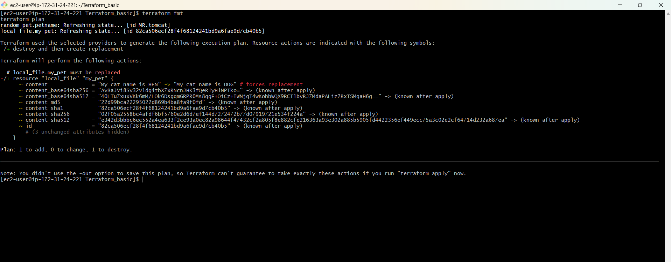
Step 2: I applied the change
terraform apply
# Enter: yes
Terraform replaced the local_file resource and completed the apply successfully.
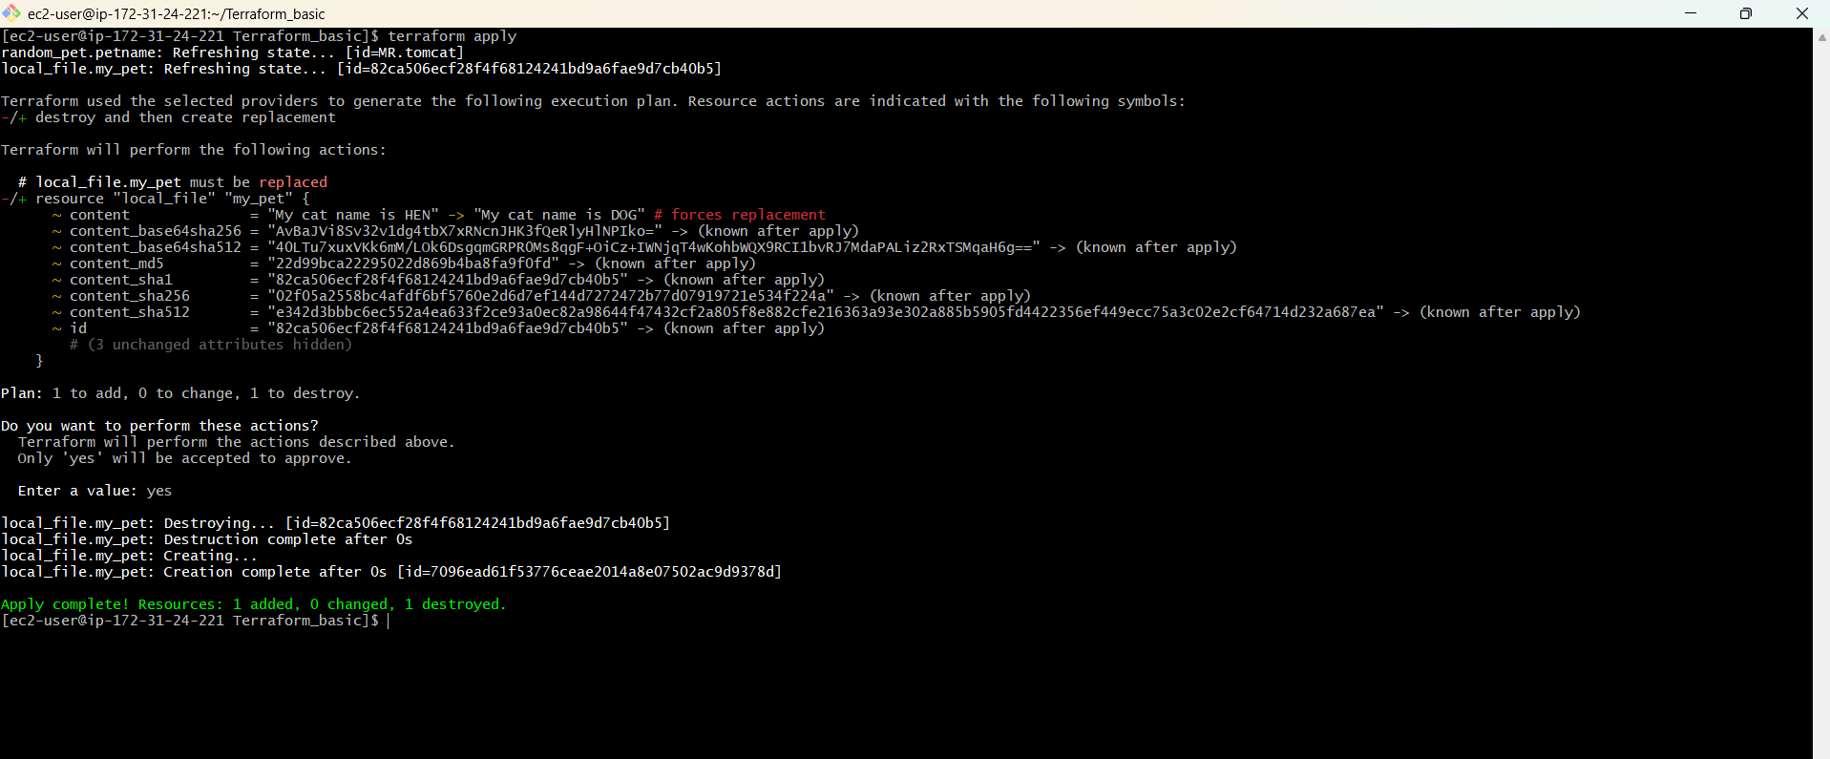

3. Terraform Lifecycle Rules
I then tested the three lifecycle rules covered by the task:
- create_before_destroy
- prevent_destroy
- ignore_changes

3.1 I tested create_before_destroy
resource "local_file" "my_pet" {
filename = "pets.txt"
content = "My cat name is DOG"
lifecycle {
create_before_destroy = true
}
}
resource "random_pet" "petname" {
prefix = "MR"
separator = "."
length = 1
}
Normally, replacement can happen as:
Destroy old
↓
Create new
With create_before_destroy = true, Terraform tries:
Create new
↓
Destroy old
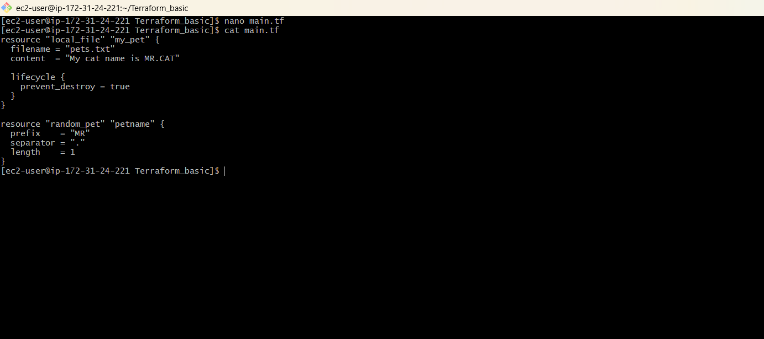
Step 1: I formatted, validated and planned
terraform fmt
terraform validate
terraform plan
The plan showed the replacement behavior.
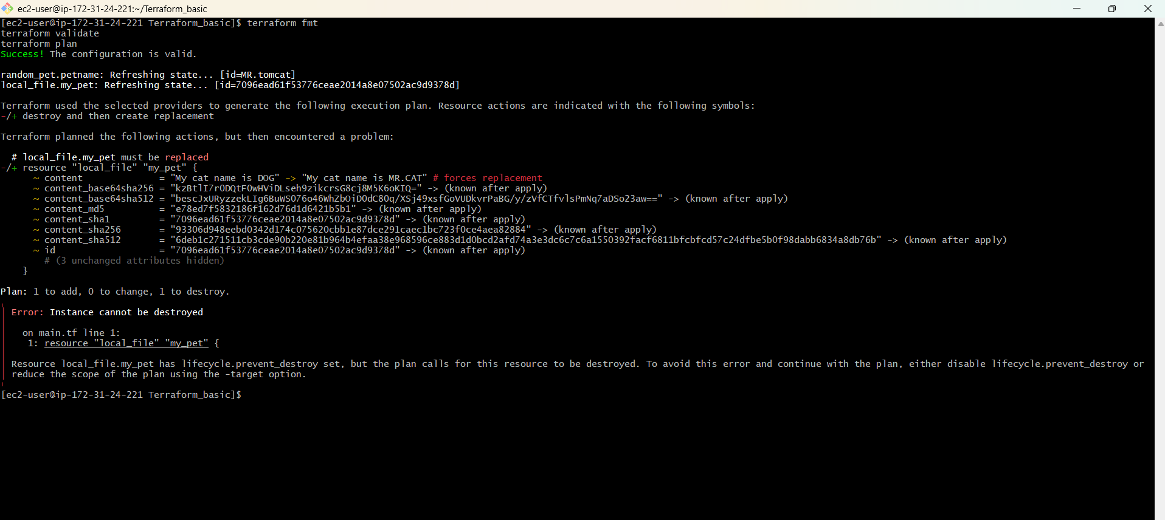
Step 2: I applied the lifecycle configuration
terraform apply
The apply output confirmed the new resource was created before the old resource was destroyed.
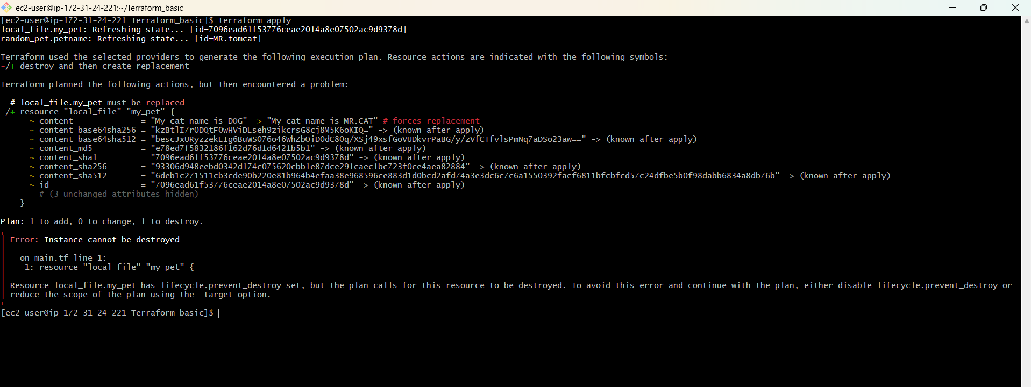

3.2 I tested prevent_destroy
resource "local_file" "my_pet" {
filename = "pets.txt"
content = "My cat name is MR.CAT"
lifecycle {
prevent_destroy = true
}
}
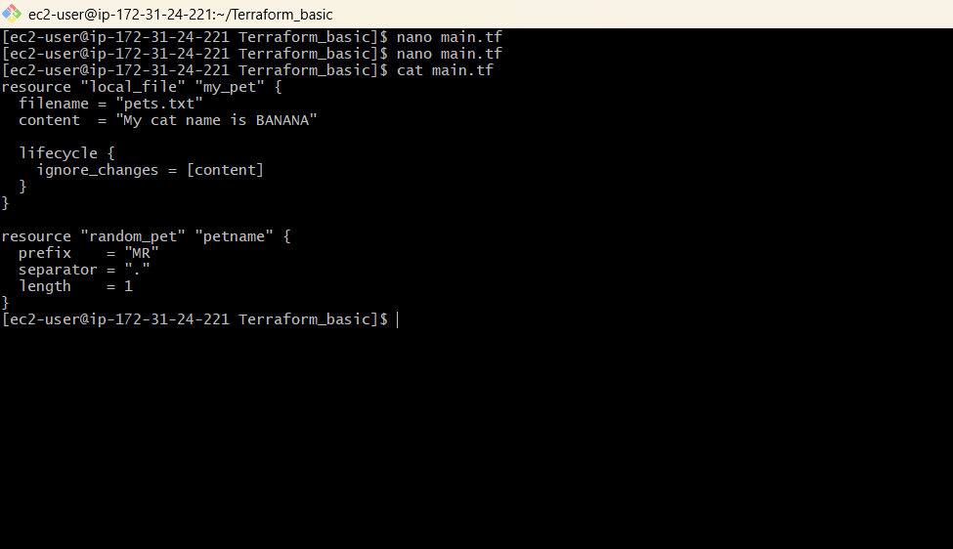Step 1: I applied the configuration
terraform fmt
terraform validate
terraform plan
terraform apply
The configuration was applied with prevent_destroy enabled.
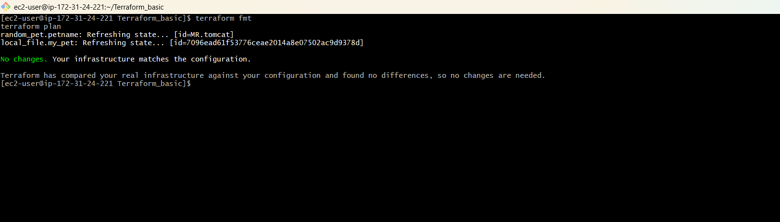
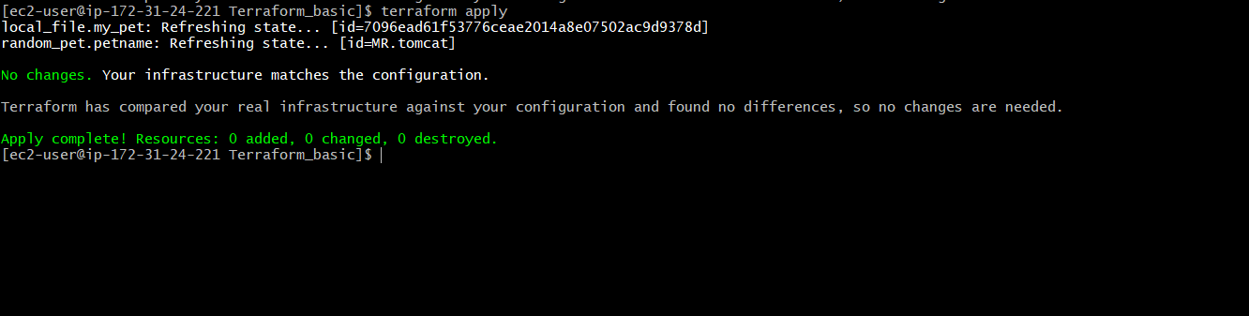
Step 2: I tested destroy protection
terraform destroy
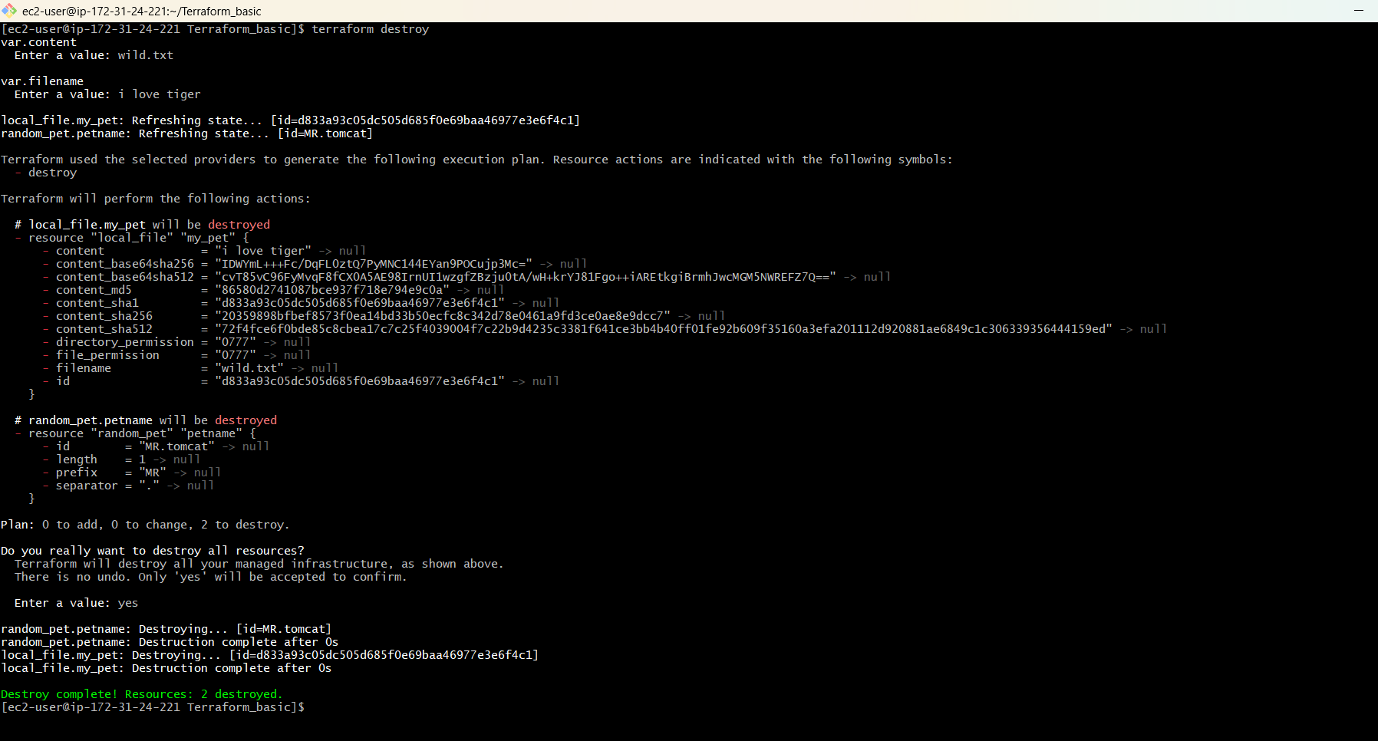
Terraform blocked destruction because lifecycle.prevent_destroy was enabled.
I understood that prevent_destroy is a Terraform configuration safeguard. It can protect important resources from accidental destruction.

3.3 I tested ignore_changes
resource "local_file" "my_pet" {
filename = "pets.txt"
content = "My cat name is BANANA"
lifecycle {
ignore_changes = [content]
}
}
resource "random_pet" "petname" {
prefix = "MR"
separator = "."
length = 1
}
Step 1: I ran the Terraform commands
terraform fmt
terraform validate
terraform plan
terraform apply
Terraform ignored the configured content difference when calculating changes. The plan reported no changes.
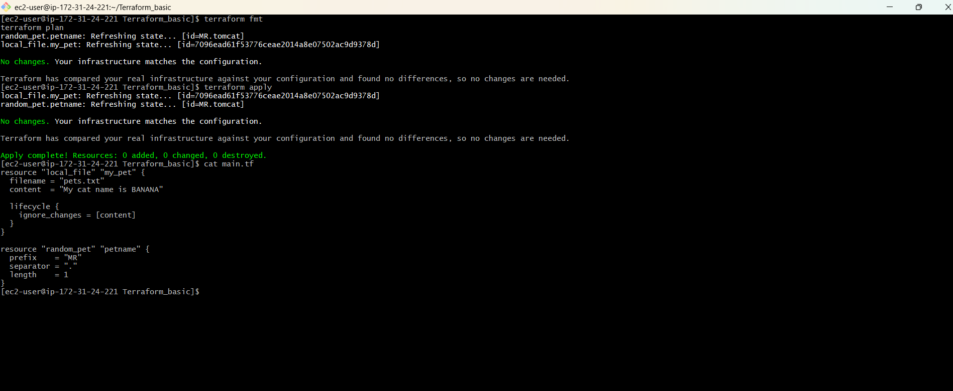

4. Terraform Variables
I replaced hard-coded values with variables so the configuration could be reused.
filename = var.filename
content = var.content

4.1 I created variables.tf
variable "filename" {
default = "pets.txt"
type = string
}
variable "content" {
default = "I love cats"
type = string
}
variable "prefix" {
default = "MR"
type = string
}
variable "length" {
default = 1
type = number
}
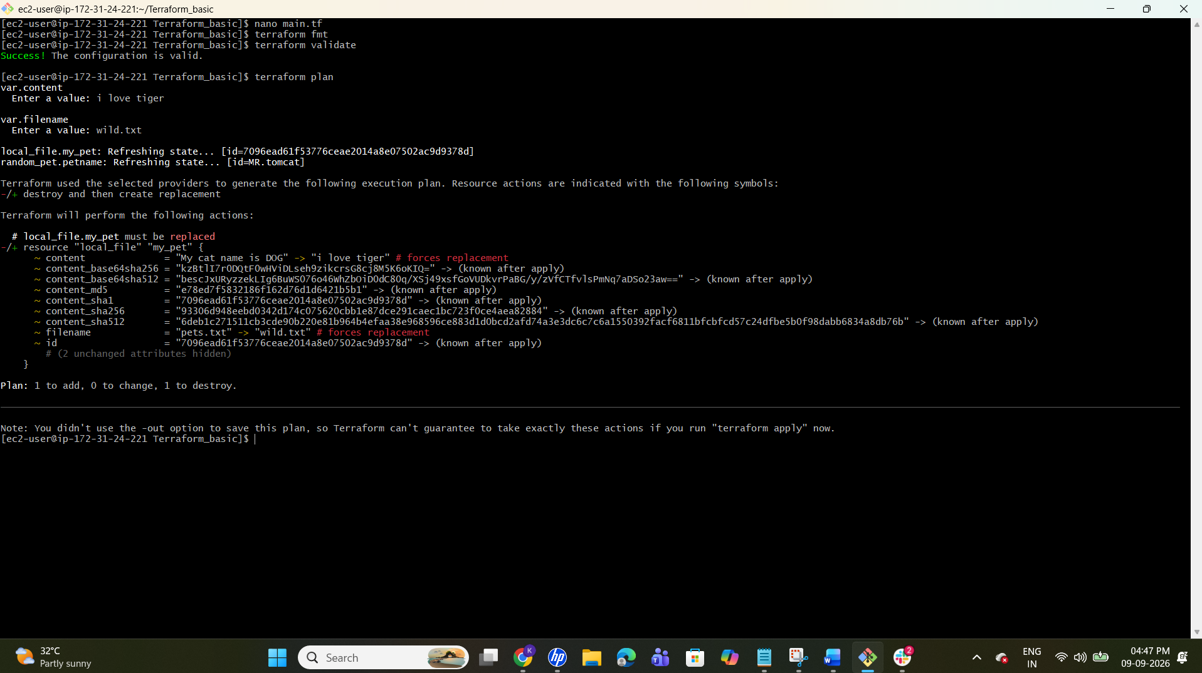

4.2 I modified main.tf
resource "local_file" "my_pet" {
filename = var.filename
content = var.content
}
resource "random_pet" "petname" {
prefix = var.prefix
separator = "."
length = var.length
}
4.3 I executed the variable-based configuration
terraform init
terraform fmt
terraform validate
terraform plan
terraform apply
The default values used were filename = pets.txt, content = I love cats, prefix = MR and length = 1.
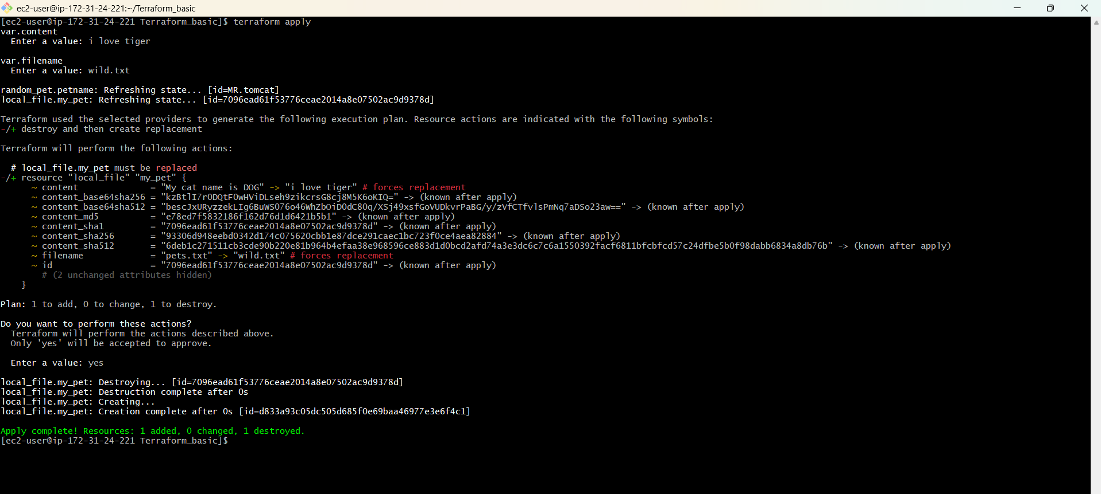

4.4 I tested variable types
Type | Example
string | "I love pets"
number | 1
bool | true / false
any | Any compatible value
list | ["cat", "dog"]
map | {pet1 = "cat", pet2 = "dog"}
object | Complex structured data
tuple | Ordered values of potentially different types

4.5 I tested variables without default values
I changed variables.tf so that filename and content had no default values.
variable "filename" {
}
variable "content" {
}
These variables required values when Terraform was run.
I also changed main.tf to use the variables for the local_file resource while keeping the random_pet values as fixed task values.
resource "local_file" "my_pet" {
filename = var.filename
content = var.content
}
resource "random_pet" "petname" {
prefix = "MR"
separator = "."
length = 1
}

Step 1: I formatted the files
terraform fmt
The Terraform files were formatted.
Step 2: I validated the configuration
terraform validate
Expected result: Success! The configuration is valid.
Step 3: I applied and provided values interactively
terraform apply
Terraform asked for the variable values. During my practical I corrected the initial interactive input by using the -var option shown below.

4.6 I tested the -var option
I provided the variable values directly from the terminal.
terraform apply -var="filename=wild.txt" -var="content=i love tiger"
Terraform used:
filename = wild.txt
content = i love tiger
When Terraform asked for approval, I entered yes.
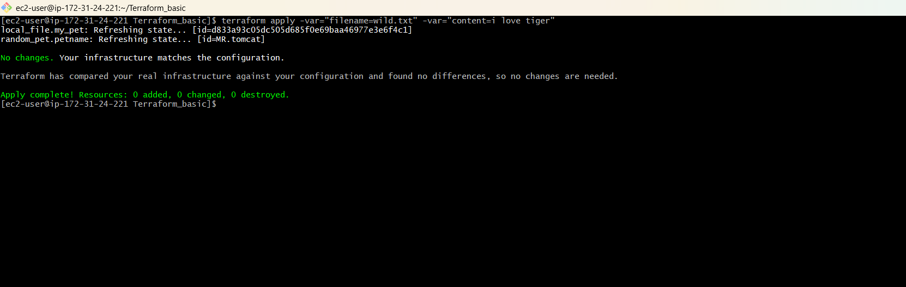

Step 7: I verified the file
ls
cat wild.txt
The file was created as wild.txt and its content was:
i love tiger
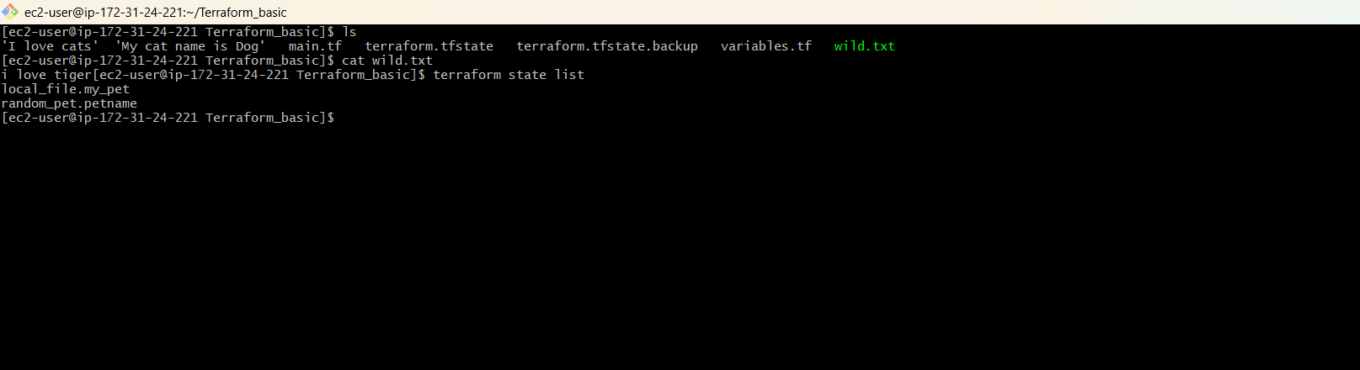

Step 8: I checked Terraform state
terraform state list
The state contained:
local_file.my_pet
random_pet.petname

5. TASK 2 – Terraform + Jenkins Integration
Overall flow
Your Terraform Code
↓
GitHub
↓
Jenkins
↓
Terraform Plugin / Tool
↓
terraform init
↓
terraform validate
↓
terraform plan
↓
AWS
For my practical, the Jenkins pipeline successfully completed the Terraform Version, Terraform Init, Terraform Validate and Terraform Plan stages.

Part 5 — Check Jenkins Prerequisites
I worked on the Jenkins EC2 server for the Jenkins integration steps.
Step 1 — Check Terraform
terraform version
My installed version was Terraform v1.16.1 on linux_amd64.
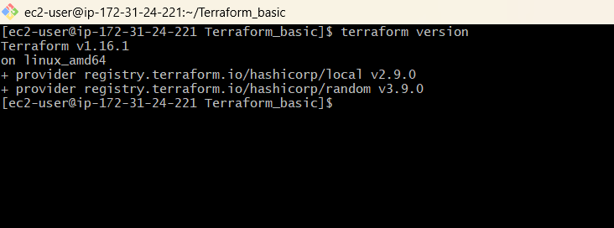
Step 2 — Check Git
git --version
My Git version was git version 2.50.1.
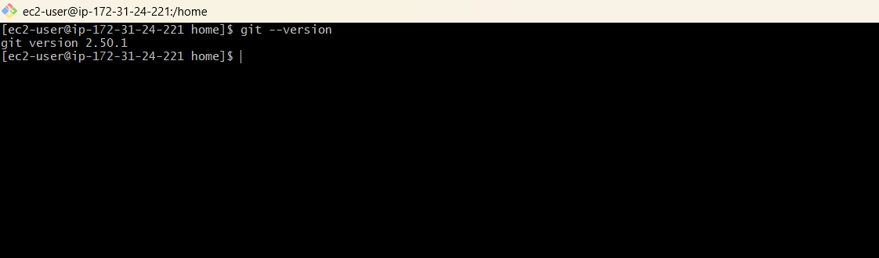
Step 3 — Check AWS CLI
aws --version
My AWS CLI version was aws-cli/2.33.15.
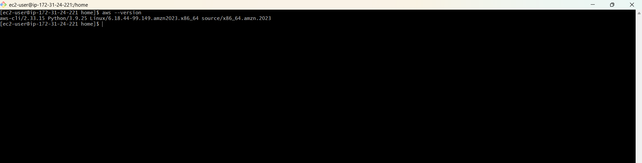
Step 4 — Check Jenkins
sudo systemctl status jenkins
Jenkins was active and running.
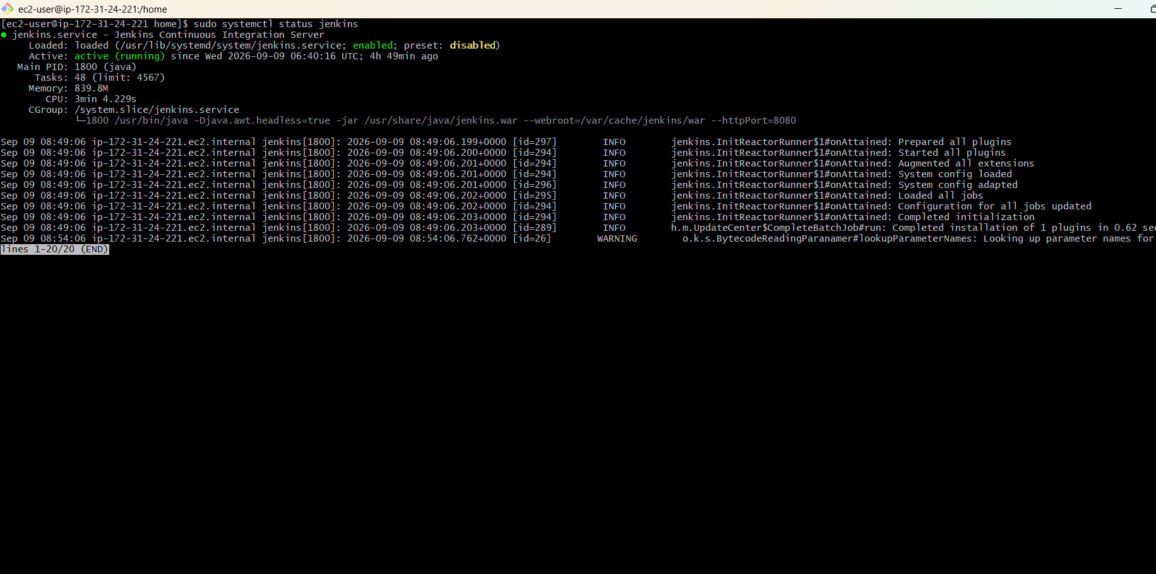

Part 5.2 — Check Terraform as Jenkins User
Jenkins runs as the jenkins user, so I verified that the Jenkins user could execute Terraform.
Step 1: Check Terraform as the normal user
terraform version
Terraform v1.16.1 was available.
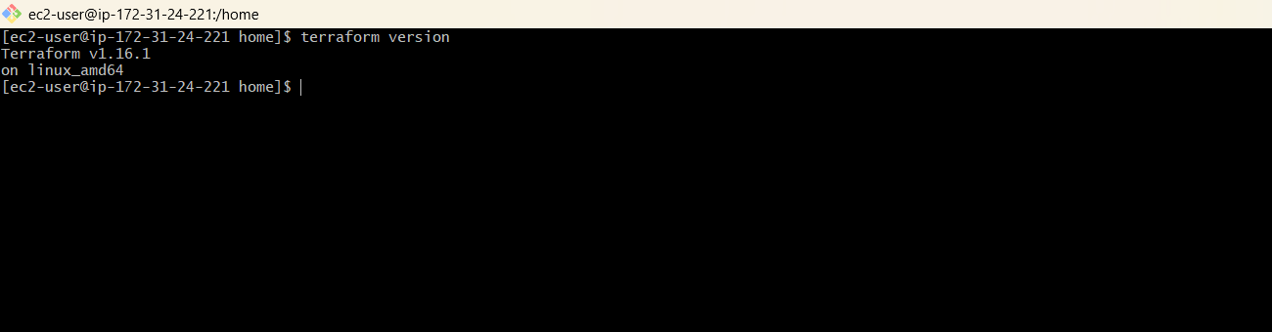
Step 2: Check Terraform as the Jenkins user
sudo -u jenkins terraform version
Terraform v1.16.1 was also available to the Jenkins user.
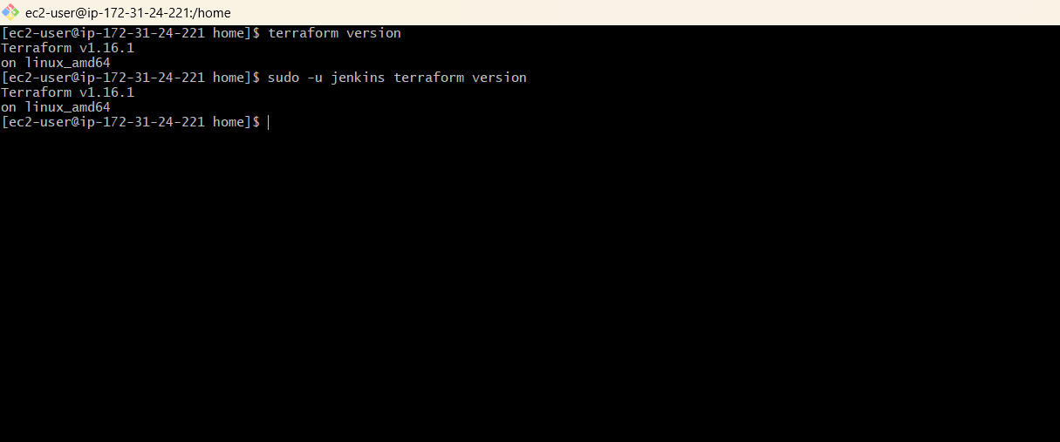

Part 5.3 — Check AWS Access
The Jenkins EC2 instance used its IAM role to access AWS.
Step 1 — Check AWS identity
aws sts get-caller-identity
The command returned the AWS account identity.
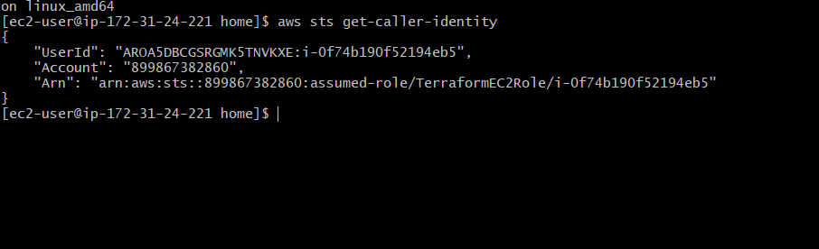

6. Create GitHub Terraform Project
I created a separate GitHub repository for the Jenkins Terraform exercise.
Repository:
terraform-jenkins
The repository contained:
terraform-jenkins/
├── main.tf
├── variables.tf
└── Jenkinsfile

Step 6.1 — Create GitHub Repository
I created the private GitHub repository and cloned it to the Jenkins EC2 environment.
git clone https://github.com/krishnasaiyalla6888-lgtm/terraform-jenkins.git
cd terraform-jenkins
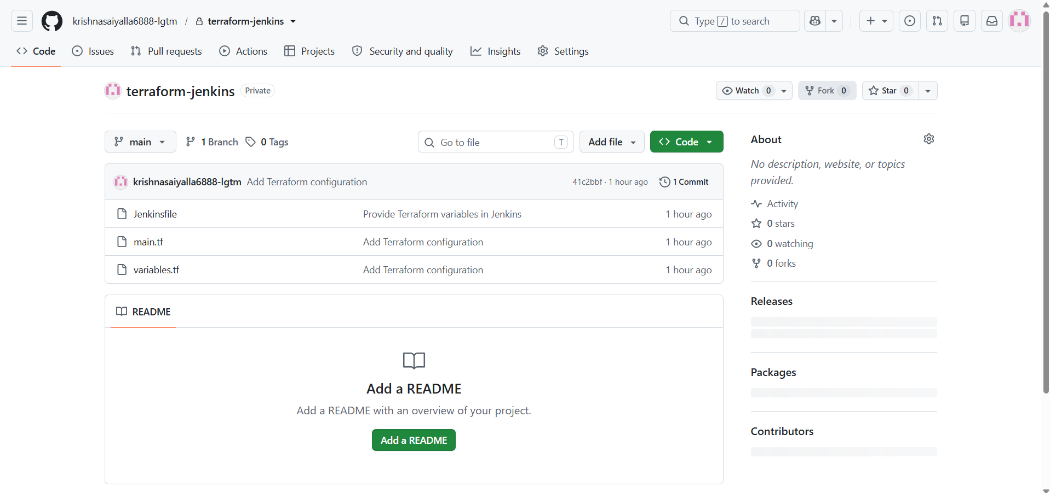

Step 6.2 — Add Terraform Files
I added the Terraform configuration used by the Jenkins pipeline.
resource "local_file" "my_pet" {
filename = var.filename
content = var.content
}
resource "random_pet" "petname" {
prefix = "MR"
separator = "."
length = 1
}
variables.tf:
variable "filename" {
}
variable "content" {
}

Step 6.3 — Initialize Git
git init
git add .
git commit -m "Add Terraform configuration"
The initial commit was created successfully.

Step 6.4 — Push to GitHub
git branch -M main
git push -u origin main
The Terraform files were pushed successfully to the private GitHub repository.

7. Install Terraform Plugin in Jenkins
In Jenkins Web UI I went to:
Jenkins
↓
Manage Jenkins
↓
Plugins
↓
Available plugins
↓
Search: Terraform
I installed the Terraform plugin and verified the commonly required Git, Pipeline and Credentials Binding plugins.

8. Configure Terraform in Jenkins
I configured Terraform under Jenkins Tools.
Manage Jenkins
↓
Tools
↓
Terraform installations
↓
Add Terraform
Installation name:
terraform
Executable path:
/usr/local/bin/terraform
I disabled automatic installation and configured the existing Terraform executable path, then saved the configuration.

9. Create Jenkins Pipeline
I created a Jenkins Pipeline job named:
terraform-jenkins
Job type:
Pipeline
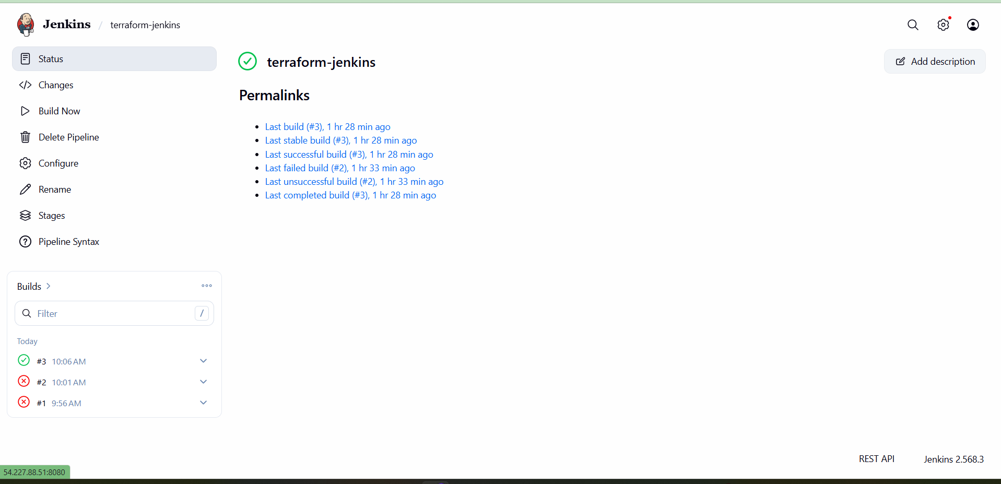

Step 9.1 — Configure Pipeline from SCM
I configured the pipeline to use the GitHub repository.
Definition: Pipeline script from SCM
SCM: Git
Repository URL:
https://github.com/krishnasaiyalla6888-lgtm/terraform-jenkins.git
Branch: */main
Script Path: Jenkinsfile
I selected the GitHub credential configured for the private repository.
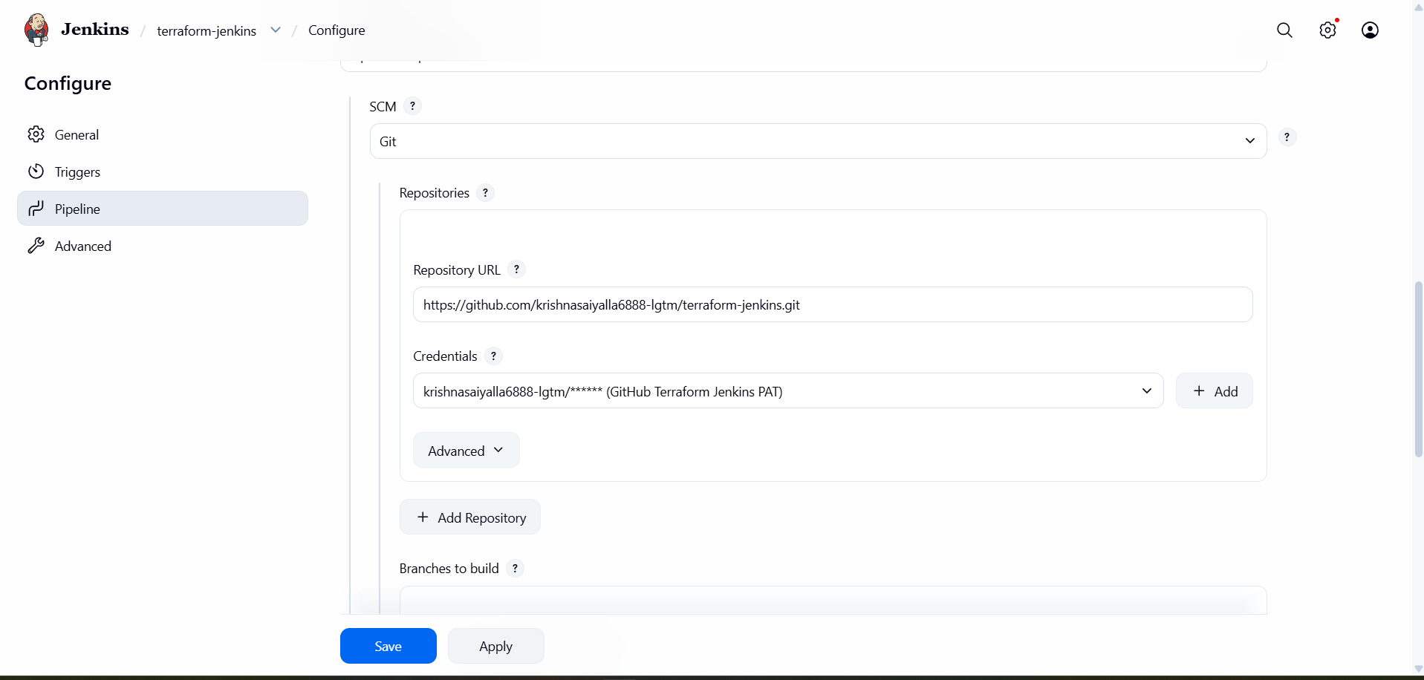

Step 9.2 — Configure GitHub Credential
Because the repository was private, I configured the GitHub credential in Jenkins and used the credential ID:
github-terraform-jenkins
This credential was used by the Jenkins checkout step.

10. Create Jenkinsfile
Inside the GitHub repository I created a file named exactly Jenkinsfile, with no extension.
Jenkinsfile
The pipeline checked out the repository and then ran Terraform version, init, validate and plan.
My completed Jenkinsfile also supplied the required variable values during terraform plan because filename and content did not have defaults.
pipeline {
agent any
stages {
stage('Checkout') {
steps {
git branch: 'main',
credentialsId: 'github-terraform-jenkins',
url: 'https://github.com/krishnasaiyalla6888-lgtm/terraform-jenkins.git'
}
}
stage('Terraform Version') {
steps {
sh 'terraform version'
}
}
stage('Terraform Init') {
steps {
sh 'terraform init'
}
}
stage('Terraform Validate') {
steps {
sh 'terraform validate'
}
}
stage('Terraform Plan') {
steps {
sh 'terraform plan -var="filename=wild.txt" -var="content=i love tiger"'
}
}
}
}

10.1 — Push Jenkinsfile
git add .
git commit -m "Add GitHub credentials to Jenkins checkout"
git push
After the first Jenkins checkout issue, I added the GitHub credential ID to the Checkout stage and pushed the correction.
git add .
git commit -m "Provide Terraform variables in Jenkins"
git push
I then pushed the final variable-supply correction so that terraform plan could run successfully in Jenkins.

11. Run Jenkins Pipeline
I opened the terraform-jenkins Jenkins job and clicked Build Now.
Jenkins
↓
terraform-jenkins
↓
Build Now
↓
Console Output
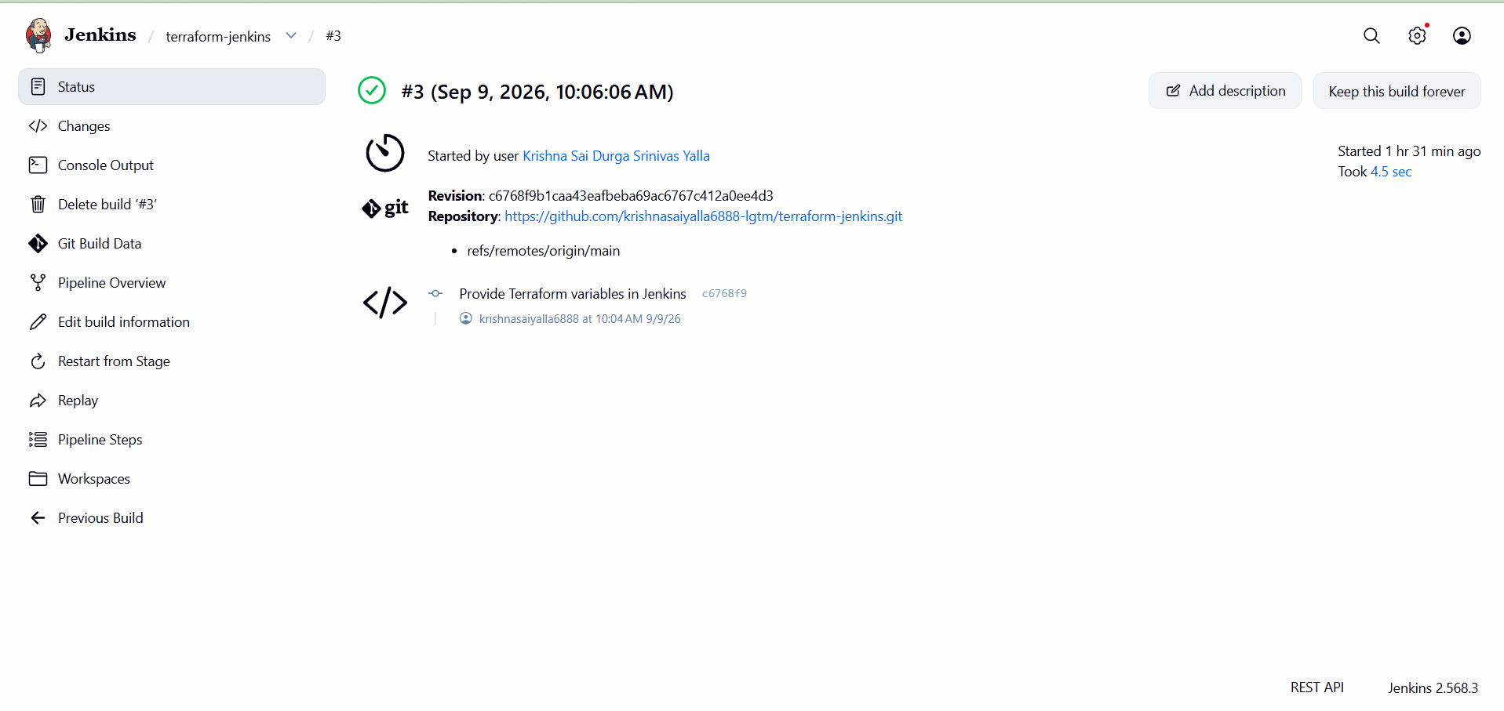

11.1 Expected Pipeline Flow
Checkout
↓
Terraform Version
↓
Terraform Init
↓
Terraform Validate
↓
Terraform Plan
The final Jenkins build completed successfully. Terraform version, initialization, validation and plan all passed.
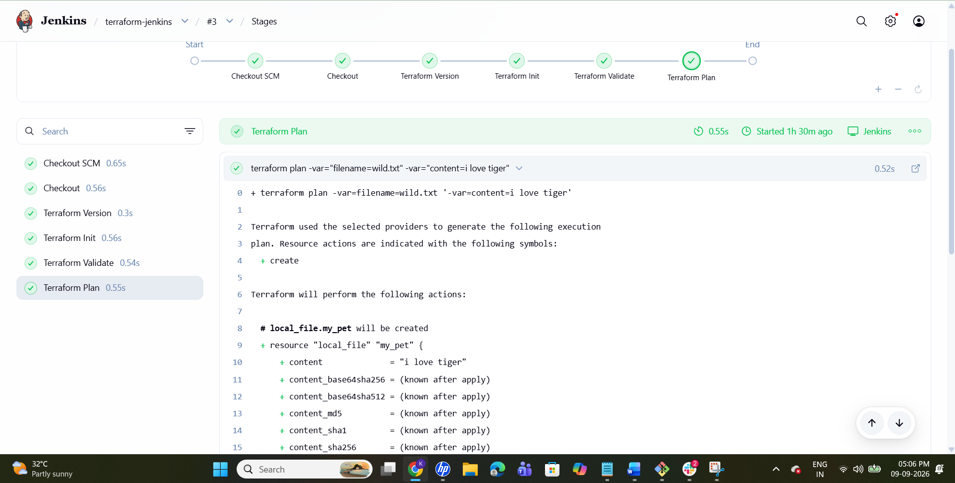

12. Final Checklist
Jenkins Server
- ☑ terraform version
- ☑ git --version
- ☑ aws --version
- ☑ Jenkins running
- ☑ sudo -u jenkins terraform version
- ☑ aws sts get-caller-identity
- ☑ sudo -u jenkins aws sts get-caller-identity
GitHub
- ☑ GitHub repository created
- ☑ main.tf
- ☑ variables.tf
- ☑ Jenkinsfile
- ☑ git add .
- ☑ git commit
- ☑ git push
Jenkins
- ☑ Terraform plugin installed
- ☑ Git plugin available
- ☑ Pipeline plugin available
- ☑ Credentials Binding plugin available
- ☑ Terraform configured under Tools
- ☑ Pipeline job created
- ☑ Pipeline script from SCM
- ☑ Git repository configured
- ☑ */main configured
- ☑ Jenkinsfile configured
- ☑ GitHub credential configured
- ☑ Build Now
- ☑ Console Output
- ☑ Terraform init successful
- ☑ Terraform validate successful
- ☑ Terraform plan successful
- ☑ Final Jenkins build SUCCESS

